

**Tadarasu Application**



Course: IT342

|  |  |
| --- | --- |
| Name | ID |
| Osama Alghofaily | 391108602 |
| Sultan Alodaib | 391107956 |
| Abdulaziz Almutari | 391108574 |
| Mohammed Alharbi | 391108712 |

**Index**

|  |  |  |
| --- | --- | --- |
| Topic | Page | Student |
| Introduction | 3 | Osama |
| Problem Statement | 3 | Osama |
| Objectives | 4 | Sultan |
| Scope | 4-5 | Abdulaziz |
| Firebase | 5-7 | Abdulaziz |
| Features expected to be added to the project | 8 | Mohammed |
| Questionnaire design and questions | 9-13 | Osama |
| Analyze the results of the questionnaire | 14-26 | Sultan & Mohammed |
| Prototype | 27-30 | Osama |
| Design and Codes | 31-34 | Osama & Abdulaziz |
| References | 35-36 | All |

**Introduction**

Tadarasu Application that combines audio-visual Islamic sciences in one place with the possibility of adding by users and creating their own lists in it in addition to a calendar for upcoming lessons.

**Problem Statement**

In our opinion, there are many problems that hinder students of Islamic sciences or normal people (who are not specialized in Islamic sciences) in searching Islamic sciences, the most prominent of which are what we have seen:

* **The large number of scholars and their differing Islamic doctrines**
* This makes the non-specialist researcher scattered, so that the path of his research or his choice of the scientist is a choice that contradicts the researcher’s doctrine
* **The many websites of scholars and the difficulty of searching for the correct ones**
* This is specifically in the case of the former scholars who died, as there is often no official website for each scholar and therefore many websites are created in which he presents his sayings, which may be for malicious purposes.
* **Difficulty searching for a specific matter**
* This particular problem is encountered by ordinary people (not specialized in Islamic sciences), for example, who find it difficult to know what department a matter belongs to or what branches of this matter are.

**Objectives Project**

* **Gathering Islamic sciences in one place**
* This includes the visual, audio and written sciences in one place in their various forms such as speeches, lectures, seminars and other formats that benefit from it.
* **Facilitating access to Islamic sciences for researcher**
* By collected and arranged in a way that facilitates the user of the application to reach faster
* **Spreading religious awareness**
* By targeting the application to all people
* **Facilitate finding lessons, lectures and courses for students of Islamic science**
* This is done by announcing about upcoming lessons, lectures and courses
* **Long application life**
* Although the idea of our application may seem common, the problem with such applications is that updates stop and therefore die at some point

**Scope**

In our mobile application project, we are targeting all people who want to know more about Islam, you can use this app to store and save all audio and visual Islamic sciences in one place, and if you have in knowledge, you can add this knowledge in the application easily.

Through the technological development and the mobile industry, we notice that paper books are gradually disappearing and the attendance lectures that are difficult to collect in one place and in our application, we make it easier for everyone to collect these books and lectures in one place and the ease of adding and storing them

**Firebase**

**What is** **firebase:**

When you design an applications like mobile applications the database is kind of big problem and not because it's hard to design, but it consumes a lot of bandwidth trafficking between a database and the application front end.

A firebase gives you a complete solution about how things can be taken down

It’s a very good solution complete back-end solution that you can put up there

Firebase allows developers to concentrate on creating amazing user experiences. You are not need to manage any servers. There's no need to develop APIs. Firebase is your server, API, and datastore, all written in a way that allows you to customize it to fit your specific needs. Yes, you'll need to leverage other parts of the Google Cloud for complex applications on occasion. It's impossible for Firebase to be everything to everyone. However, it comes close.

**Functions firebase:**

**Authentication firebase:** In firebase you can do all sort of authentication are by:

1. Email / Password (most common)
2. Phone
3. Anonymous
4. Google Account
5. Facebook Account
6. Twitter Account
7. Play Games Account
8. Game Center Account
9. Apple Account
10. GitHub Account
11. Microsoft Account
12. Yahoo Account

It also allows you to customize custom templates for each message:

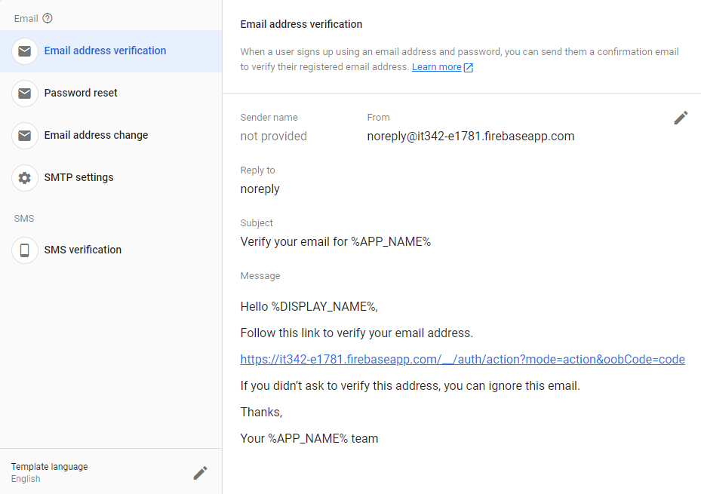

**Realtime Database:** When you connect your app to Firebase, you're not using standard HTTP to do so. You're using a WebSocket to connect. HTTP is considerably, much slower than WebSocket's. You don't need to perform many WebSocket calls because a single socket connection suffices. All of your data syncs automatically as fast as your client's network can handle it across that single WebSocket.

As soon as fresh data is available, Firebase provides it to you. When your client saves a change to the data, the revised data is sent to all linked clients nearly quickly.

**Firestore Database:** Firebase's newest database for mobile app development is Cloud Firestore. With a new, more understandable data model, it builds on the triumphs of the Realtime Database. Cloud Firestore also has more powerful, quicker searches and is more scalable than Realtime Database.

**Storage firebase:** Firebase Storage allows you to save binary files — most commonly photos, but anything goes — straight to Google Cloud Storage from the client!

To safeguard your G-Cloud bucket from the masses, Firebase Storage has its own set of security restrictions, while allowing comprehensive write capabilities to your authenticated customers.

**Hosting firebase:** For all of your static files, Firebase features an easy-to-use hosting solution. It uses HTTP/2 to deliver them from a worldwide CDN.

And, to make development even easier, Firebase hosting makes use of Superstatic, which you can use for all of your testing locally.

The development environment for BrowserSync + Superstatic is quite nice. BrowserSync reloads your development app across all connected devices, while Superstatic replicates Firebase hosting locally so you can push directly to Firebase for production usage.

There are also many pre-installed services such as "Functions" and "Machine Learning", and many services that you can install later such as "Run Payments with Stripe" and others

**Features expected to be added to the project**

* **Save to read later**
* Adding the content that the user would like to return to for later reading to a list linked to his own account in order to save the user's time
* **A calendar of upcoming lectures, lessons and courses**
* An online calendar that contains upcoming lectures and lessons, whether in presence or remotely, with the ability to save them in the calendar application on the user's phone
* **Translating articles and visual content**
* This is by adding the "zTranslate" tool to video content, and "Google translate" for articles.
* **Discussion system**
* Adding a discussion system at the bottom of each published content in order to exchange opinions and ideas
* **Allow users to add content themselves**
* This is in order to ensure that the application will live as long as possible even without an actual administration, knowing that there will be an algorithm for content filtering in addition to another voting algorithm by users to filter content

**Questionnaire design and questions**

|  |  |
| --- | --- |
|  |  |
|  |  |
|  |  |
|  |  |
|  |  |
|  |  |
|  |  |
|  |  |
|  |  |

* You can view the survey directly from here [https://survey.porsline.com/s/p62yv9FV](https://survey.porsline.com/s/p62yv9FV%20)
* The questionnaire service "[Porsline](https://porsline.com/)" was chosen for the possibility of setting better terms and design than the rest of the services

**Analyze the results of the questionnaire**

We also saw that the highest proportion of people participating in the survey were female (52%), however this is a very good percentage (approximately 50%), meaning that the answer to this questionnaire came out almost equally between the gender's male and female.

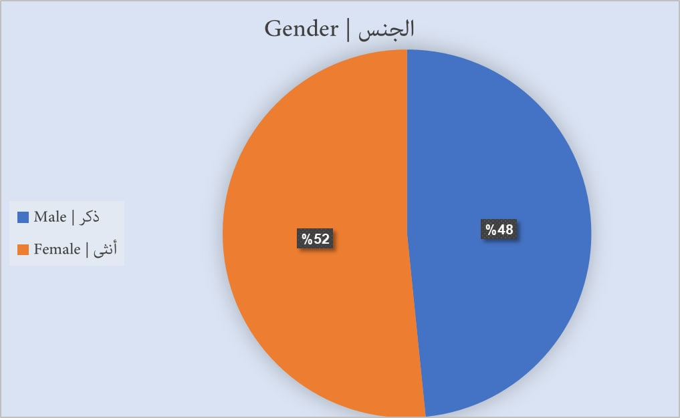

We see that a big percentage (62%) of the people who did this questionnaire are between 19-25 and after that (18%) are people whose ages are 26-32 after that 32 and more (14%) and at least (6%) are between 12-18, this gives us a conclusion that the results of this survey will be based on the orientation of the younger generation.

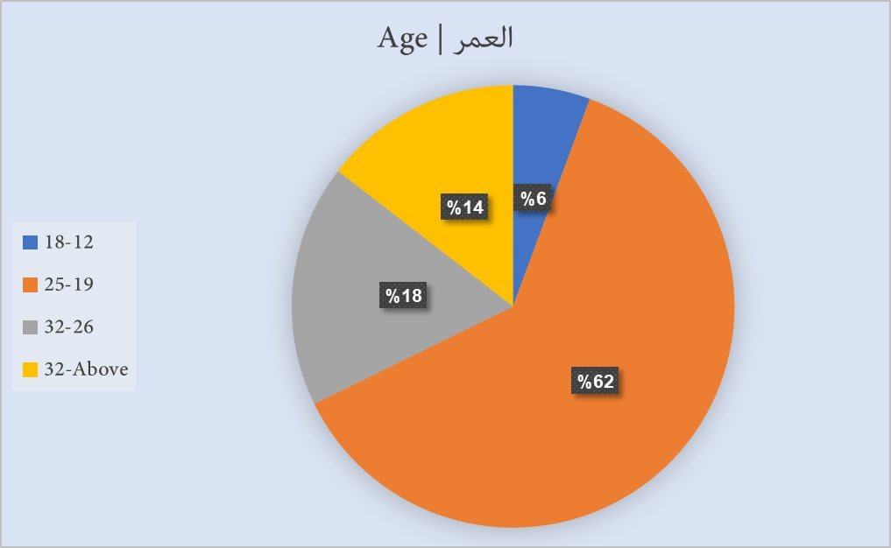

As we see in this survey the big percentage goes to whose interests in Islamic science in (41%) after that comes the answer no in (31%) and after that the answer yes at percentage (27%), so we conclude that the majority of participants in this survey are interested in or study Islamic sciences.

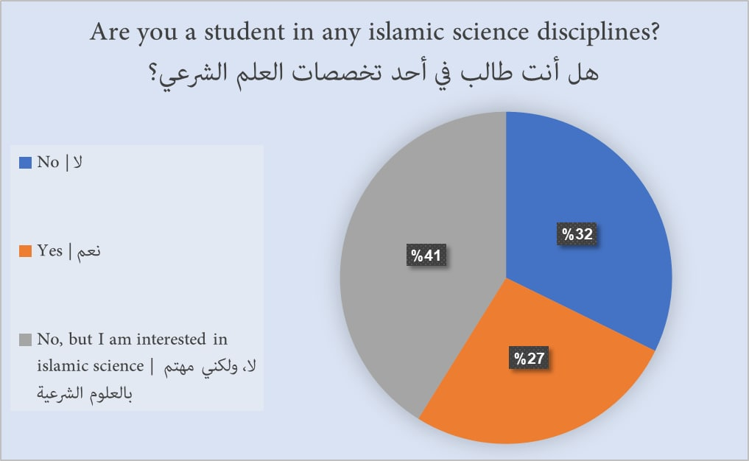

As we see the percentage are so close and the answer get the highest rate is (Not interested in a specific way) after that (written) after that (Audible)at least is (Visual), we understand from that the people need information in any way served to them.

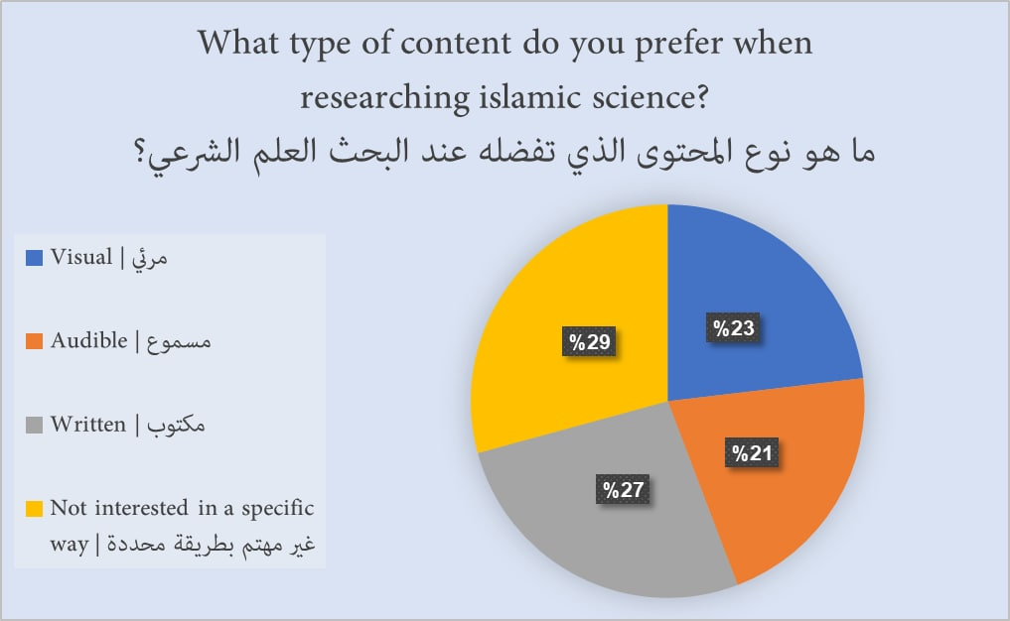

The survey said most of the people get the information in online way after that they have no specific way at least the live meeting (face-to-face) way, as we see the smallest percentage goes to live meeting because the social media effects so people need the easier way to get the information.

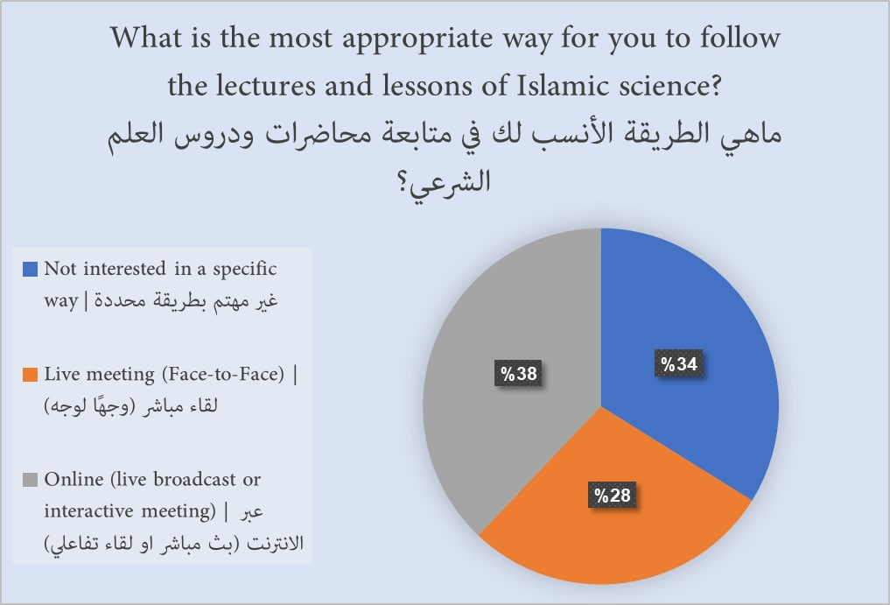

As we see in survey the most people have distracted in percentage of (63%) and the own who have it sometimes is (23%) at least (13%) whose have not distraction in searching, so we decide to prepare our application to solve this problem.

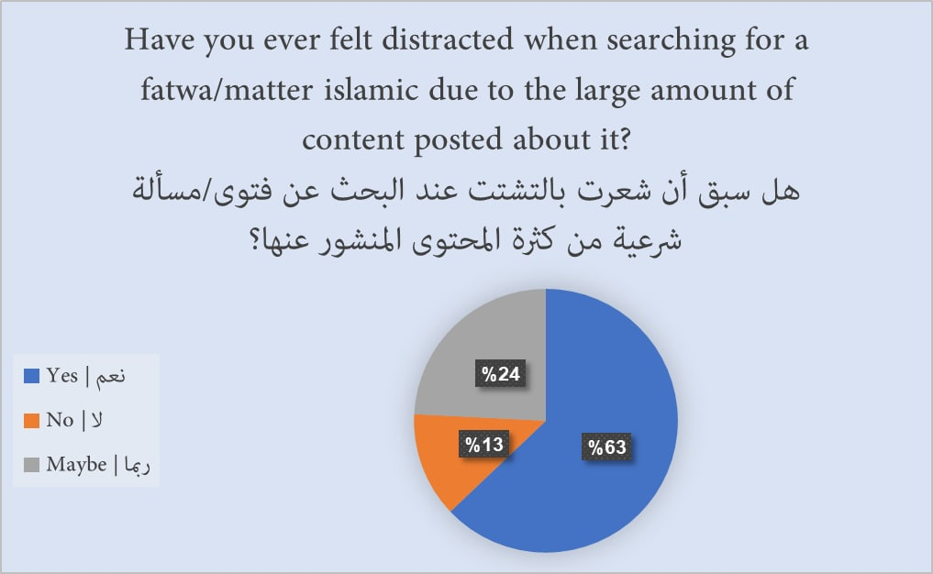

The highest percentage goes to Yes after that goes to No in order (57%) to Yes and (43%) to No, so the people are divided half of them lesson to specific scientist and the other half lesson to anyone.

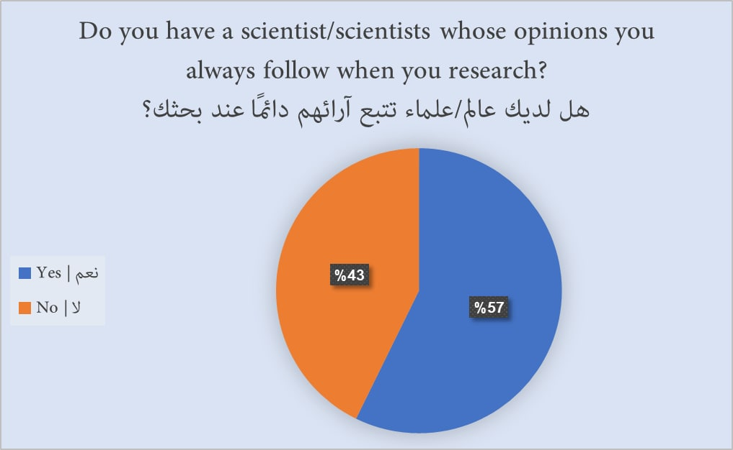

As we see almost huge numbers of people write (محمد العثيمين) and (عبدالعزيز ابن باز) in order 45 to 40 and others like we see in the graph, we Analyst that a lot of people lesson from specific scientist.

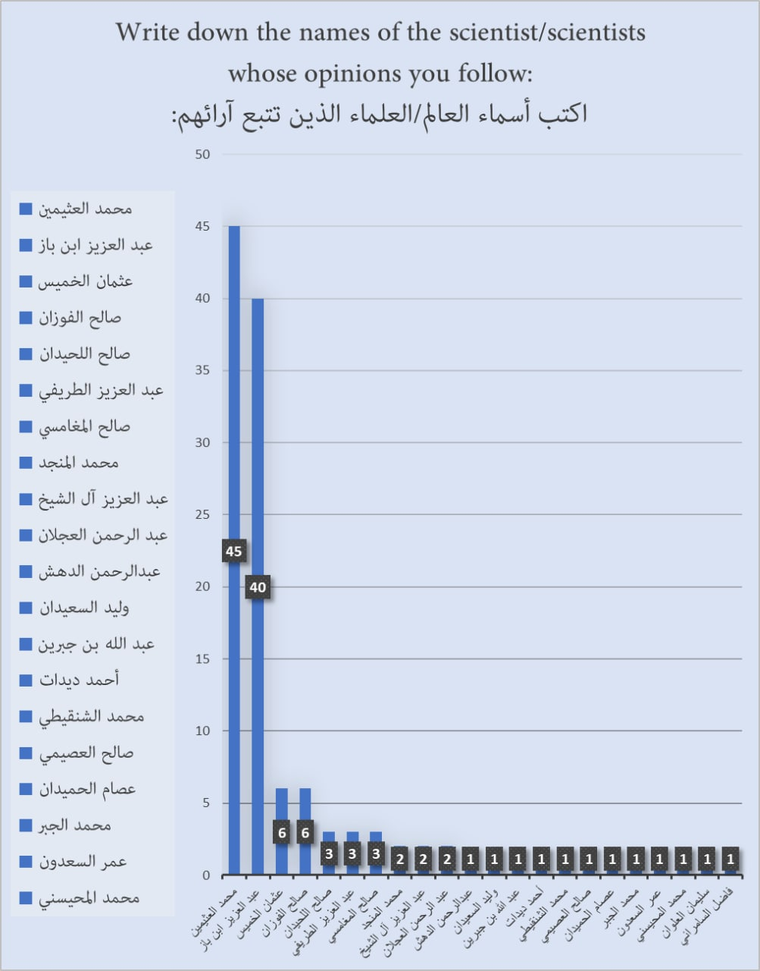

As survey shows a lot of people have difficulty to find an Islamic lectures and lessons in percentage of (67%) and (33%) percentage whose have no problem in it .so we in our applications solve this problem and make lectures and lessons easy to find.

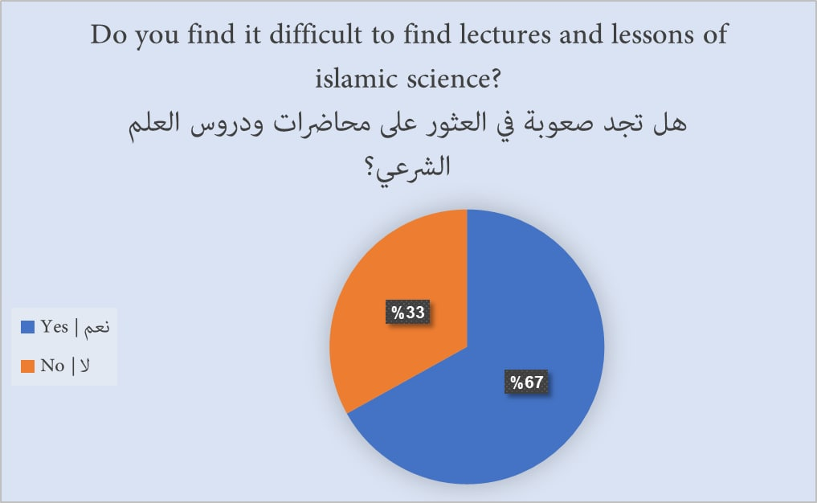

We asked those who answered “no” in the last question about how they found the lectures and lessons of Islamic science, and after cleaning the data, we concluded that the majority of people watch videos (22 votes) or search in search engines (16 votes) to find lectures and lessons of Islamic science

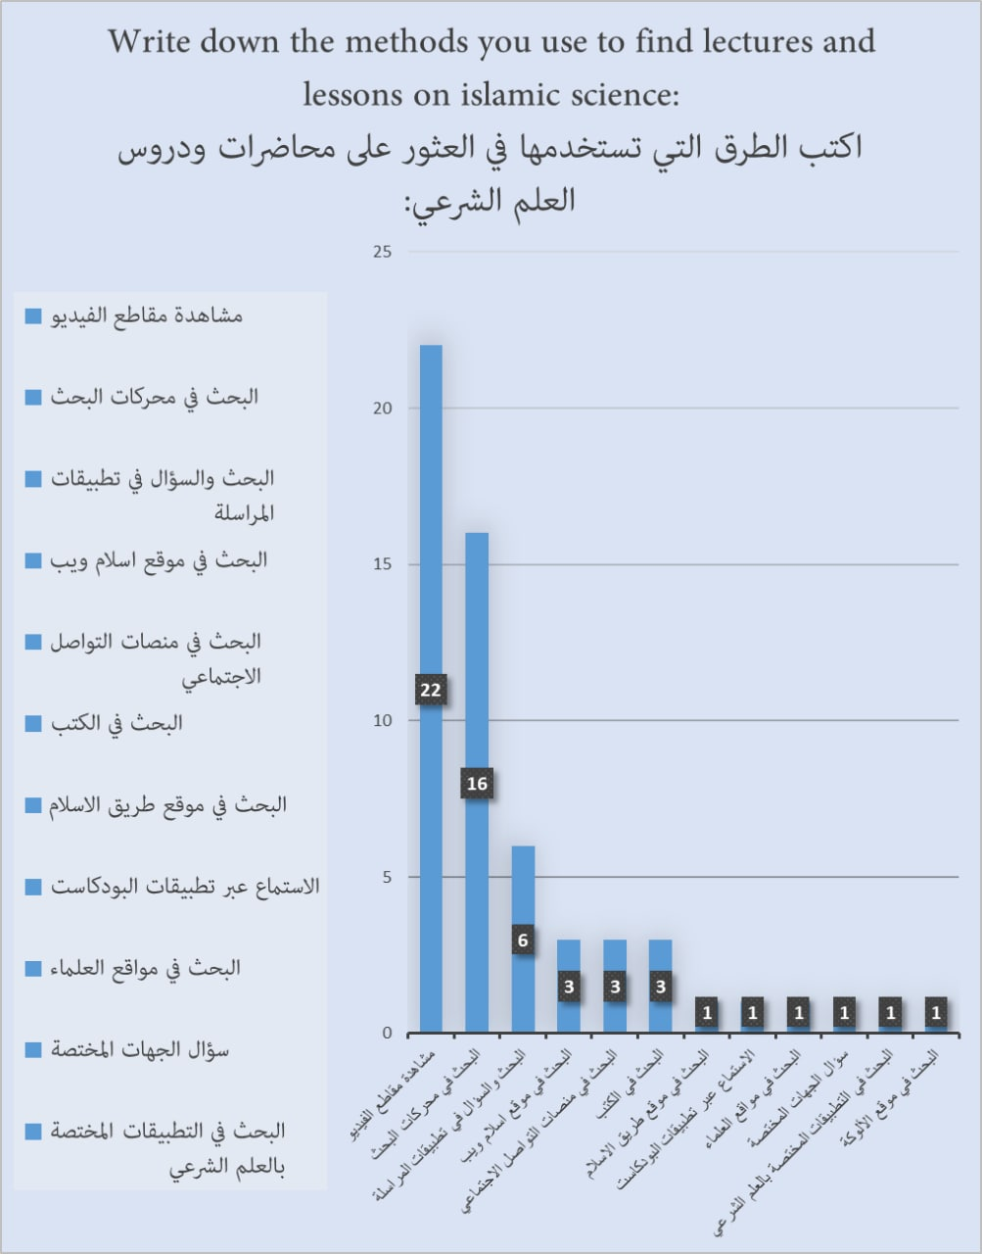

The survey shows a lot of people never used an Islamic application in percentage (66%) and the rest shown in graph,

So that gives us big challenge because most of people never used Islamic application before so we make our application easier to use and more convenient.

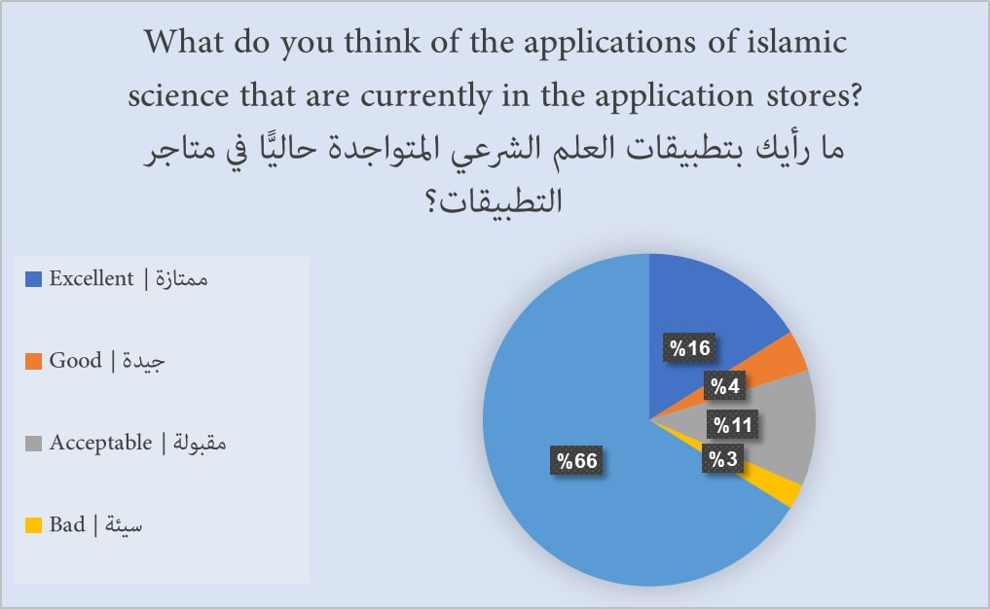

We see in graph a small number of apps people are using, so our ambition to create an application that becomes known and useful to a lot numbers of people.

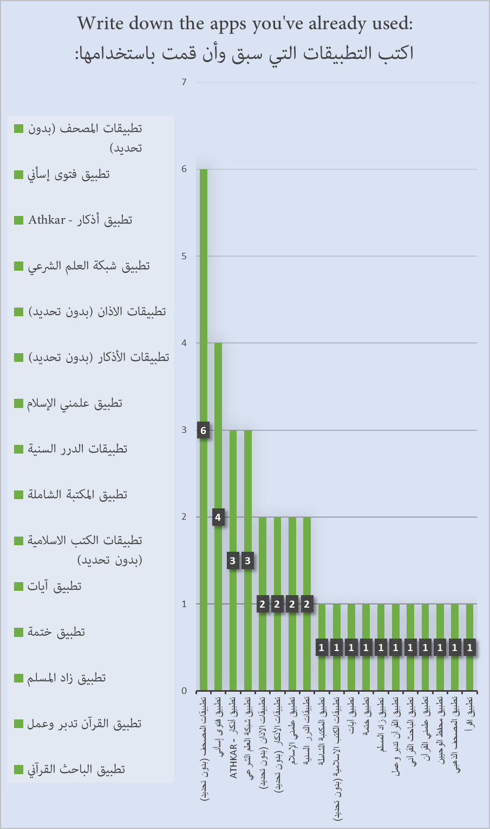

Since we see the highest percentage in our survey (69%) saying yes and (31%) the percentage saying no, we conclude that there is room for expansion later in adding other languages to the app

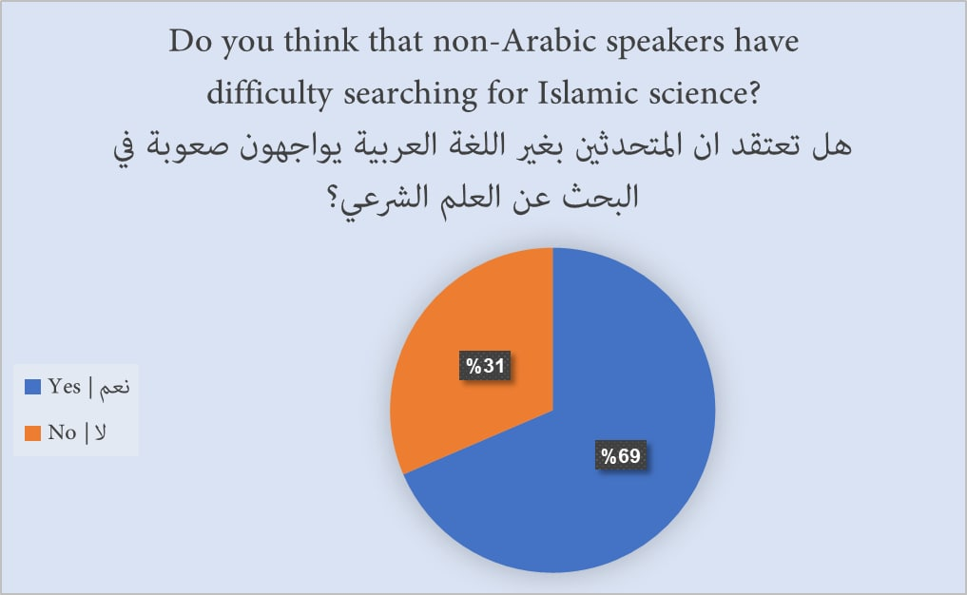

We put a number between 1 to 5 to see the importance of translations the visual and written content so we see a lot of people choose 1 and it is means isn't important to put this feature in our application.

In addition to some problems, the automatic translation is inaccurate, and therefore we fear that this may cause confusion among non-Arabic speakers

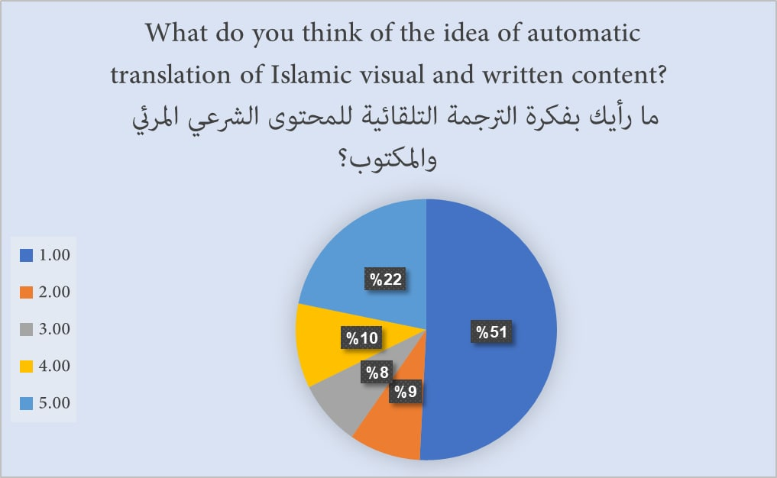

In order 1 to 5 (1 means bad and 5 is good) our survey shows most of people want to see application in apps store that allows discussion the Islamic science.

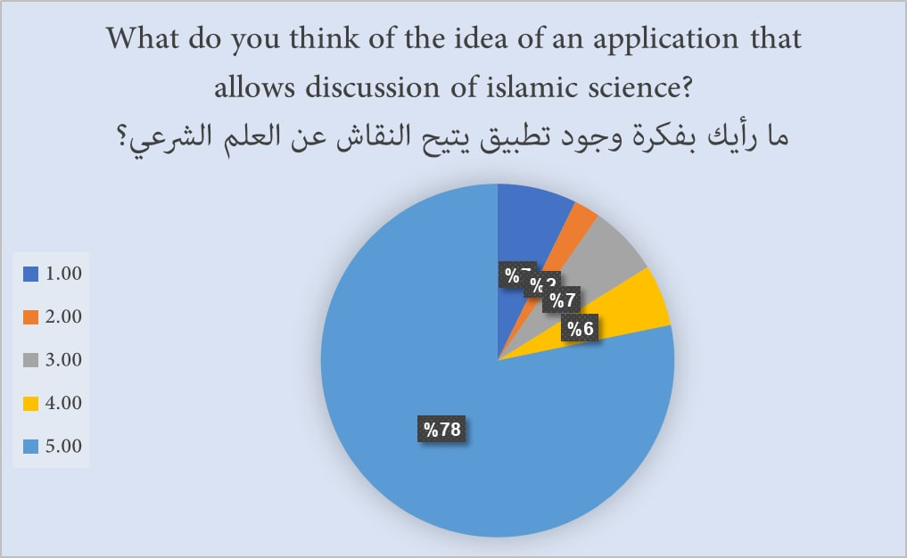

Our survey showed that almost all of the people indicated that they had to refer to Islamic content after viewing it, so we in our app have included a feature that enables you to save the content you have read before to make it easier.

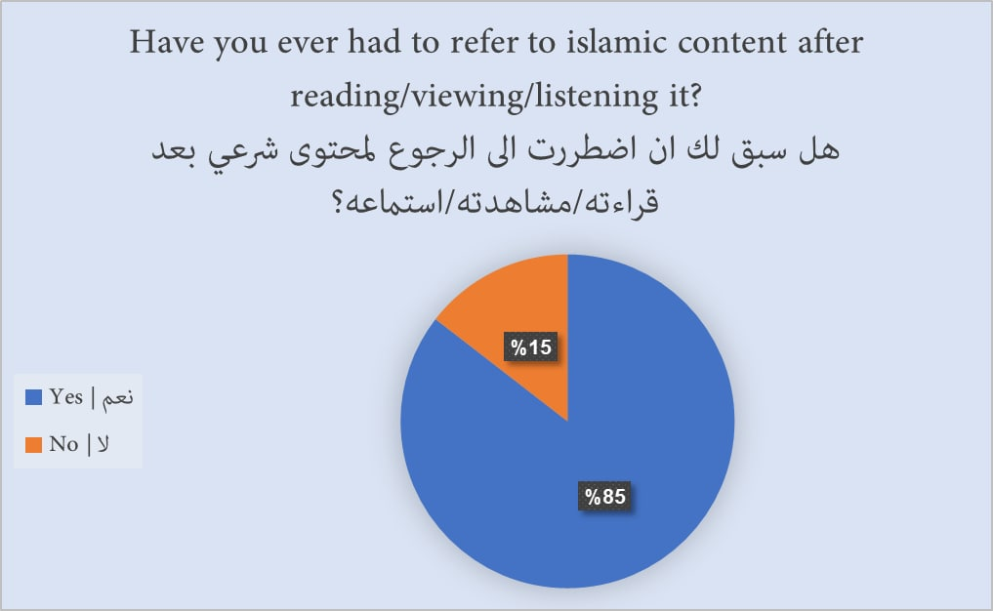

**Prototype**

We made the prototype based on the data that was previously given to us in the questionnaire, you can watch us live [here](https://www.figma.com/proto/R7se5a70L8AhwBD1KsQaw3/Tadarasu?node-id=57%3A98) (<https://www.figma.com/proto/R7se5a70L8AhwBD1KsQaw3/Tadarasu?node-id=57%3A98>)

|  |  |
| --- | --- |
| Login Page | |
| It is the page that appears to you when you open the application for the *first time*, and it includes:   1. Login/register via email 2. Login/register through social networks (Google, Facebook, Twitter) 3. Recover the password for registered accounts via email 4. Follow up as a guest |  |

|  |  |
| --- | --- |
| Home Page | |
|  |  |
| It is the page that will appear to you after logging in / logging in as a guest through the application and includes the following:   1. A list displaying the published content (and can be customized according to all categories or a custom category) 2. Search box 3. The ability to add content to the reading list later through an icon in the content image | |

|  |  |
| --- | --- |
| Calendar Page | |
| This is a page that contains a calendar of upcoming lectures, lessons and courses and allows you to:   1. The ability to export the event to the phone's calendar 2. It allows viewing previous and upcoming lectures, lessons and courses through an easy calendar that allows you to view according to the day, month and year |  |

|  |  |
| --- | --- |
| Read Later Page | |
| It is a page that contains what the user has saved from the content that allows him to read it later with ease |  |

|  |  |  |
| --- | --- | --- |
| Content Page | | |
| *Example of article content* | *Example of video content* | *Example of audio content* |
| It is the page that displays content of all kinds (visual, audio, and written), and its properties are:   1. When adding visual content, the source must be YouTube, for several reasons: 2. Compatibility with all devices without any problems 3. Staying away from problems of property and intellectual rights, as YouTube monitors the clips and ensures that they are free of problems 4. When adding audio content, the source must be an mp3 file for the following reasons: 5. Compatibility with all devices without the need to apply additional applications that may annoy users with their advertisements 6. The lack of a sufficiently powerful platform to monitor intellectual property rights problems (such as YouTube in visual content) 7. The ability to add content to the Reading Later list through an icon located in the top bar of the page 8. There is a bar below the content that contains the following data: 9. The name of the sheikh who owns the original content 10. Tags that can be used to easily access relevant content 11. A comment system that allows users to discuss the published content | | |

**Design and Codes**

After we finished designing a prototype, we started copying the design into our app in Android Studio

This is the result after designing and programming all pages:

|  |  |  |
| --- | --- | --- |
| Login/Register/Reset Password Pages Insert Action Update Action | | |
| *MainActivity.java* | *Register.java* | *ResetPassword.java* |

|  |  |
| --- | --- |
| Home Page (Home.java) | |
|  |  |

|  |  |  |
| --- | --- | --- |
| Content Page (SingleContent.java) Insert Action Delete Action | | |
| *Video Content* | *Sound Content* | *Article Content* |

|  |  |
| --- | --- |
| Add Content Page (AddContent.java) Insert Action | |
|  |  |

|  |  |  |
| --- | --- | --- |
| Bookmarks Page (Bookmarks.java) Update Action Delete Action | | |
| *Bookmark's view & data personal* | *In click change name* | *In click delete account* |

|  |
| --- |
| Search Page (Search.java) |
|  |

**References:**

* https://www.figma.com/community/file/1087092786661212228
* https://www.figma.com/community/file/1006926488179586509
* https://www.figma.com/community/file/1061219180114211452
* https://www.figma.com/file/yc9o4p5SAc882LLNU5g5WV/project
* https://binbaz.org.sa/
* https://binothaimeen.net/site
* https://www.youtube.com/playlist?list=PLIW7Uli0gP7h2wvikTq5zMh8PoOQWhlpw
* https://play.google.com/store/apps/details?id=com.tamayyuzcenter.huffazulmutoon
* https://play.google.com/store/apps/details?id=softagi.ss.sc
* https://play.google.com/store/apps/details?id=com.edeltasoft.tafsir
* https://play.google.com/store/apps/details?id=com.appbits.Sanad
* https://porsline.com/ar/
* https://howtofirebase.com/what-is-firebase-fcb8614ba442
* https://stackoverflow.com/questions/47433654/how-to-delete-selected-item-from-firebase-database
* https://stackoverflow.com/questions/38114689/how-to-delete-a-firebase-user-from-android-app
* https://stackoverflow.com/questions/48904039/is-it-possible-to-update-only-specific-data-on-my-child-on-firebase
* https://github.com/PierfrancescoSoffritti/android-youtube-player
* https://jagar.me/post/voicemessagesview/
* https://github.com/JagarYousef/ChatVoicePlayer
* https://www.youtube.com/c/StevdzaSan/videos
* https://www.youtube.com/playlist?list=PL65Ccv9j4eZJ_bg0TlmxA7ZNbS8IMyl5i
* https://www.youtube.com/playlist?list=PLGCjwl1RrtcSvDCxDfJb-eqwneCe934mv
* https://www.youtube.com/playlist?list=PLDKucuCBdlJacuFlSOpy3wi30ezUKzH2v
* https://www.youtube.com/playlist?list=PLGCjwl1RrtcR4ptHvrc_PQIxDBB5MGiJA
* https://www.youtube.com/playlist?list=PLs1bCj3TvmWmtQbEzNewkf-UhBJ2pFr5n
* https://www.youtube.com/playlist?list=PLs1bCj3TvmWlQRNJ1lPZOoAy184YCLheu
* https://stackoverflow.com/questions/45658501/loading-image-from-server-using-glide-in-viewholder
* https://stackoverflow.com/questions/57467025/how-to-intent-an-image-that-loaded-from-the-internet-by-glide
* https://stackoverflow.com/questions/58442167/load-image-from-server-using-glide